**<<** **IN 1901 - Microcontroller Based Application Development Project>>**

**PROJECT PROPOSAL REPORT**

**Level 01**

**Smart Path Finder**

Examiner: Mr. B. H. Sudantha < >

**Submitted by:**

**K.A.A.S. Kodithuwakku 224226C**

U.J.M.V. Bhashitha 224024F

R.M.M.N. Ranasinga 224250T

U.C.P. De Silva 224034K

K.J.M. Amarasiri 224008K

Bachelor of Information Technology

Faculty of Information Technology

University of Moratuwa

**Table of Contents**

1. Introduction 2

1.1 Problem in Brief 3

1.2 Significance of Study 3

1.3 Aim and Objectives 3

2. Literature Study 4

3. Proposed Solution 5

3.1 Features of the Proposed Solution 6

3.2 Components required for the proposed solution 6

3.3 Nature of the Solution 8

Figure 01: Block diagram of the input, process and output 9

3.4 Solution Design 9

Main checkpoint at the entrance 10

Resources 12

3.5 Workload Matrix 12

4. References 13

# Introduction

Navigating the sprawling grounds of the University of Moratuwa poses a common challenge for visitors with specific tasks, often leading to inefficiencies and frustrations. Recognizing this predicament, a proposed path-finding system aims to streamline the visitor experience within the university premises. Much like contemporary navigation solutions that simplify complex journeys, the system is designed to offer a user-friendly and efficient means for visitors to locate precise destinations, ensuring a seamless and pleasant experience.

## Problem in Brief

The common challenge addressed by this project is the difficulty faced by visitors arriving at the University of Moratuwa in navigating the premises for specific tasks. Navigational challenges hinder a seamless experience for visitors who may struggle to locate specific places within the university, impacting their overall efficiency and experience. The proposed system aims to resolve this issue by introducing an advanced navigation system, providing visitors with a seamless path-finding experience. By implementing an efficient navigation solution, the project attempts to offer visitors a convenient and user-friendly way to find exact locations within the premises, thereby optimizing their time and improving their overall experience.

## Significance of Study

The proposed path-finding system at the University of Moratuwa holds significant importance as it aims to ease the common challenge faced by visitors in navigating the expansive university premises. By streamlining the visitor experience through clear and efficient routes, the system not only enhances overall satisfaction and saves valuable time, but also reflects the university's commitment to embracing technological advancements for the benefit of its visitors. The user-friendly design ensures accessibility for all, contributing to a positive first impression and fostering a welcoming and organized environment within the university premises.

## Aim and Objectives

**Aim:**

To enhance the visitor experience at the University of Moratuwa by implementing an advanced navigation system, utilizing RFID technology, to provide seamless path-finding within the university premises.

**Objectives:**

* To design and implement a system that efficiently guides visitors to specific locations within the University of Moratuwa.
* To develop a programmable RFID card system for visitors upon entry, encoding information about their intended destination.
* To establish checkpoints strategically placed throughout the university premises, corresponding to various locations and providing clear directions to visitors.
* To provide visitors with a clear road map to their desired destination, minimizing confusion and optimizing the path-finding experience.
* To facilitate swift and effective navigation for individuals by utilizing RFID technology and eliminating the challenges associated with finding specific places.
* To implement a system that streamlines the workflow for visitors, ensuring a seamless and effective navigation process.
* To define three key locations within the university premises to be navigated and establish checkpoints to guide visitors between these locations.
* To develop a checkpoint system that provides clear directions for the desired location with respect to the visitor's current checkpoint.

# Literature Study

Navigating the vast and intricate layout of the University of Moratuwa can present challenges for visitors with specific tasks, potentially leading to inefficiencies and frustrations. In response to this common issue, a proposed path-finding system aims to revolutionize the visitor experience within the university premises. The proposed system simplifies complex journeys, offering visitors a user-friendly way to find their destinations effortlessly, ensuring a smooth and enjoyable experience. The integration of a programmable RFID card system offers a novel approach to path-finding, encoding destination information upon entry and guiding individuals through strategically placed checkpoints. This innovation enhances the overall efficiency and satisfaction of visitors navigating the diverse landscape of the University of Moratuwa.

To further emphasize the user-centric design of the proposed navigation system, the implementation plan focuses on defining three key locations for navigation and strategically positioning checkpoints along the designated route. This approach ensures that visitors are seamlessly directed to their intended destinations, minimizing the likelihood of confusion or delays. The proposed navigating system prioritizes simplicity and clarity, in line with current trends in navigation technology, where user experience is crucial for success. The proposed RFID card and checkpoint system offers a promising avenue for addressing the challenges faced by visitors, transforming the University of Moratuwa into a more accessible and visitor-friendly institution.

# Proposed Solution

Our innovative Tracker System is designed to prioritize the safety and security of visitors within the premises. This solution ensures controlled access and oversight, with centralized operation managed through the security office at the entrance of the university.

## Features of the Proposed Solution

* In the navigation project, visitors are issued programmable RFID cards containing information about their intended destinations. These RFID cards are read by checkpoints strategically placed throughout the university, providing a clear roadmap to guide visitors to their desired locations.
* The ESP32 microcontroller processes the RFID data, implementing a navigation algorithm to calculate the most efficient routes based on the destination information.
* Additionally, a fingerprint access system is integrated into the project, allowing administrators to securely enter the network and control the programming of RFID cards. The system operates on a Li-Ion battery, ensuring portability and flexibility. A voltage regulator (AMS1117) stabilizes the power supply for reliable operation.
* The SIM800L module enables communication capabilities, allowing the ESP32 to communicate with a central server or admin interface. This facilitates real-time updates and data exchange. The entire system aims to streamline visitor navigation within the institute, enhancing efficiency, and contributing to a more effective workflow.

## Components required for the proposed solution

1. ESP 32

The ESP32, serving as the central microcontroller, efficiently processes data, interfaces with RFID readers to extract information from visitors' RFID cards, communicates with the SIM800L module for network-related tasks, and exercises overall control over the system's functionality.

1. RFID card and reader

RFID cards and readers are employed for destination encoding and reading. These cards are coded with the destination at the security office of the entrance and later assist in finding out the optimized route for their destination for the visitor when tapped at the RFID reader at checkpoints. They contribute to the efficient navigation for visitors while simultaneously enabling them to self-check their current location at checkpoints.

1. SIM 800L

The SIM800L is an integral component, whose primary task is facilitating seamless communication with the ESP32 microcontroller. Through this communication channel, the SIM800L module enables the navigation system to establish and maintain connectivity over the cellular network to facilitate the efficient exchange of data.

1. Voltage Regulator

The Voltage Regulator (model number: SRD-05VDC-SL-C relay module), is a key component in the navigation system project, that ensures a power supply by regulating the voltage. Its common usage and reliability make it an ideal choice for maintaining a consistent 3.3V, meeting the specific requirements of the ESP32 microcontroller. This regulator plays a crucial role in ensuring the safety of components of the system, contributing to its overall efficiency and reliability.

1. Fingerprint Sensor

Fingerprint sensors serve as efficient and secure authenticators for accessing administration portals, preventing unauthorized users from gaining entry. By scanning and verifying unique fingerprint patterns, these sensors provide a quick and reliable means of confirming user identities. This biometric authentication method enhances security and adds an additional layer of protection to administration portals, reducing the risk of data breaches or unauthorized access.

1. Buzzer

The buzzer serves as an auditory alert system to notify users. It produces a distinctive sound to draw attention to specific actions, warnings, or notifications within the system. By emitting audible signals, the buzzer enhances user awareness and helps ensure timely responses when the user successfully taps the RFID card on the reader and when the fingerprint sensor gets an input.

1. LCD Display (Liquid Crystal Display)

The LCD display acts as a user-friendly interface, offering real-time updates on access to the administration portal, regarding the inputs received by the fingerprint sensor. It communicates the status of access grants in a clear format, enhancing interaction between the system and the administrator. By providing easily understandable information, the LCD fosters effective communication and facilitates smooth administration portal management.

## Nature of the Solution

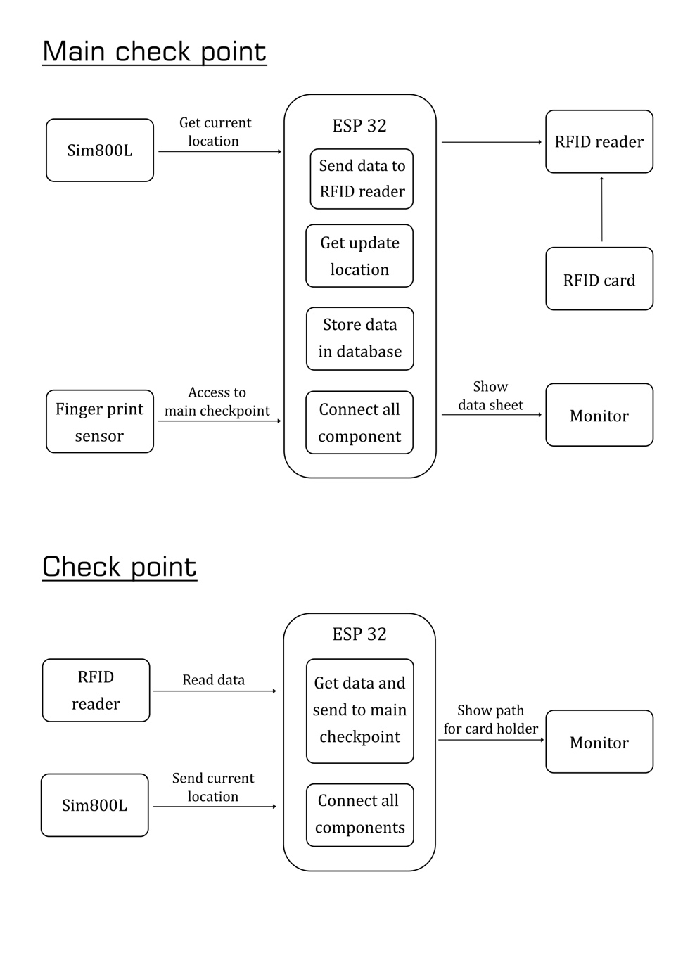

## Figure 01: Block diagram of the input, process and output

## Solution Design

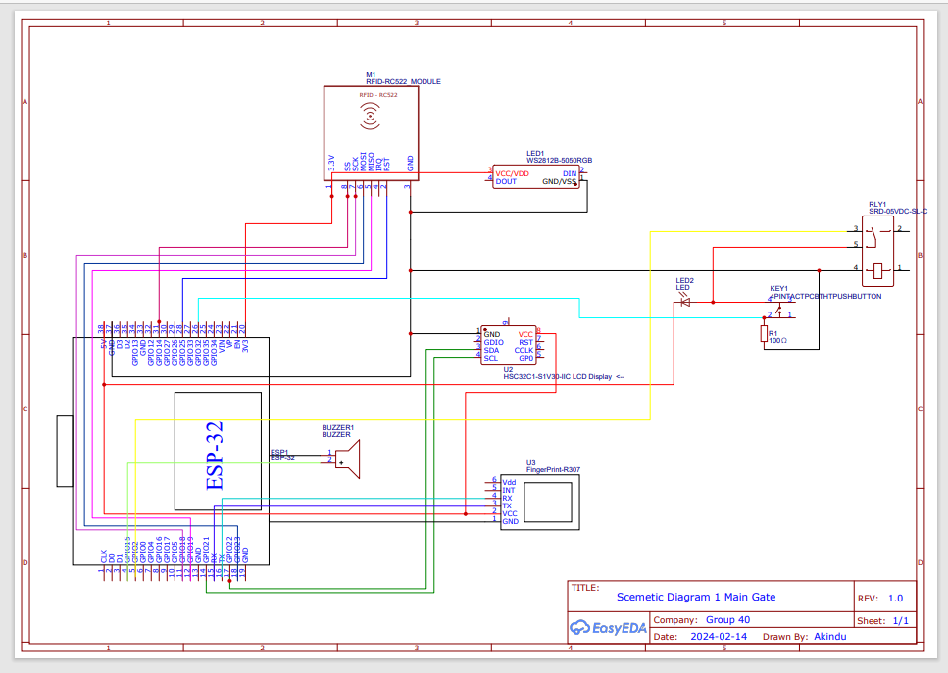

## Main checkpoint at the entrance

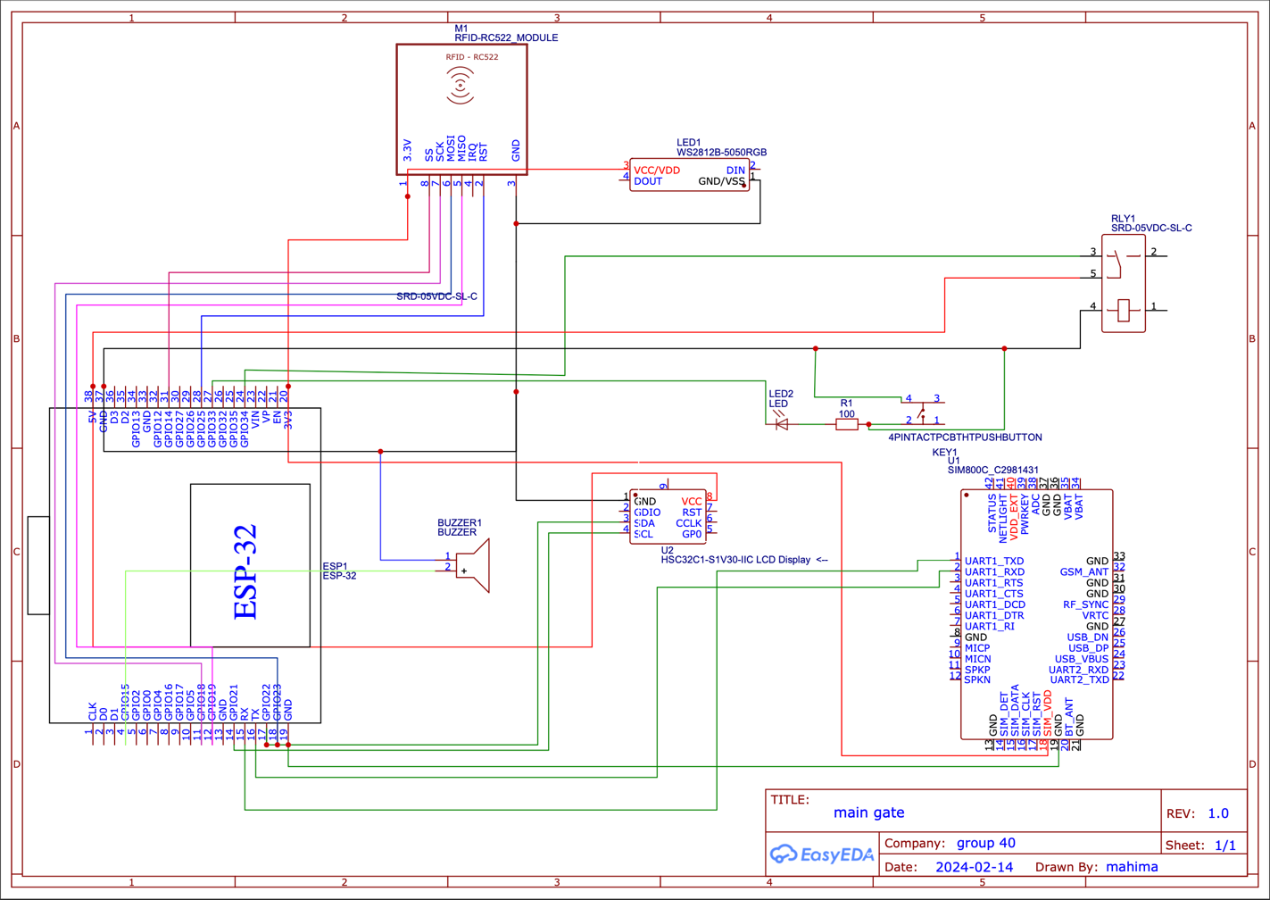Secondary check points

## Resources

**Table 01: Components with budget allocation**

|  |  |  |  |
| --- | --- | --- | --- |
| **Component** | **Unit Price (LKR)** | **Unit** | **Total Price** |
| ESP32DevKit V1 | 2045.00 | 4 | 8180.00 |
| RC522 RFID Reader Module | 530.00 | 4 | 2120.00 |
| MIFARE Classic 1K RFID cards | 270.00 | 4 | 1080.00 |
| Voltage Regulator (SRD-05VDC-SL-C Relay) | 800.00 | 4 | 3200.00 |
| SIM 800L | 1150.00 | 4 | 6600.00 |
| Fingerprint sensor module R305 | 4000.00 | 1 | 4000.00 |
| Plastic Box | 250.00 | 4 | 1000.00 |
| 12V Jump wires (Male to Female Jumper Wires (40 pcs, 20cm length)) supply | 160.00 | 2 | 320.00 |
| 12 V Jump wires (Male to Male Jumper Wires (40 pcs, 20cm length)) supply | 180.00 | 2 | 360.00 |
| PCB design | 8000.00 | 1 | 8000.00 |
| Monitor | Will be provided | 4 | Will be provided |
| Buzzer | 140.00 | 4 | 560.00 |
| NeoPixel Ring | 500.00 | 4 | 2000.00 |
| LCD display | 400.00 | 4 | 1600.00 |
| **Total** | | | 39,020.00 |

## Workload Matrix

In here you should mention how the development of the solution has been divided among group members and the expected contribution of each member to the group project.

**Table 02: Workload Matrix**

|  |  |
| --- | --- |
| Registration Number | Assigned Responsibilities |
| 224226C | PCB Design  Website design |
| 224024C | SIM 800L  Wi-Fi  Website design |
| 224250T | Finger Fingerprint sensor module R305  Power  Website design |
| 224034K | RC522 RFID Reader Module  Website design |
| 224008K | Buzzer  NeoPixel Ring  Outer look  Website design |

# References

IEEE Xplore (https://ieeexplore.ieee.org/)

ACM Digital Library (https://dl.acm.org/)

SpringerLink (https://link.springer.com/)

ScienceDirect (https://www.sciencedirect.com/)

"RFID Handbook: Fundamentals and Applications in Contactless Smart Cards, Radio Frequency Identification and Near-Field Communication" by Klaus Finkenzeller

"Wireless Sensor Networks: Principles, Design, and Applications" by S. Sitharama Iyengar, Richard R. Brooks, and Marimuthu Palaniswami

"Internet of Things (IoT): Principles and Paradigms" edited by Rajkumar Buyya, Amir Vahid Dastjerdi, and Sriram Krishnamurthi